1. We first created the Zod validation schema in the validators and checked for the password confirm and password match

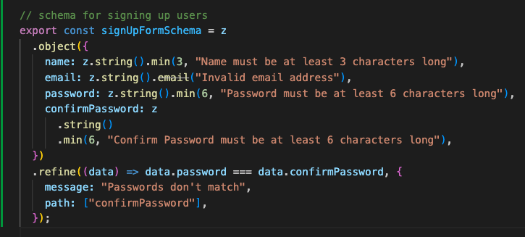

1. And now we imported that in our user actions and created the sign-up user

